**Year 11 ATAR Integrated Science**

**Comparison of Two Local Ecosystems Assessment**

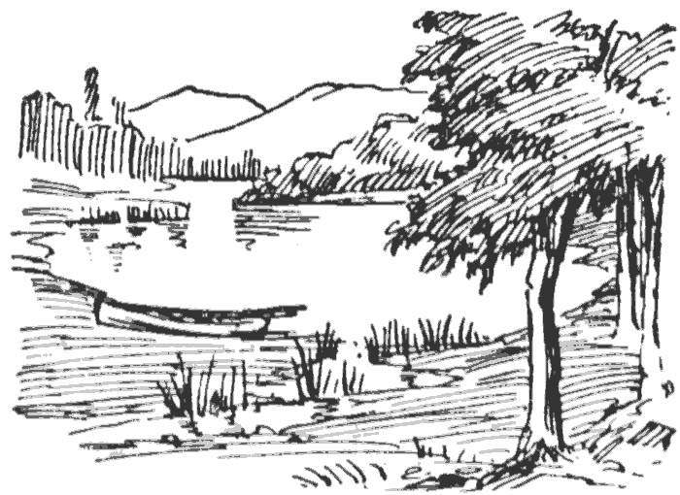

**Comparison of Two Local Ecosystems**

**Using Ecological Monitoring Techniques**

Name: _______________________ Group Members: _______________________________________________

**Student Hypothesis and Rationale**

If some non-living factors are more important in determining what plants and animals can or cannot survive in this area, then

I think that (choose one: temperature, humidity, rainfall, or wind) is the most important non-living factor affecting plant and aquatic animal life, because _______________________________________________________________

Which Location do you predict would be the heathiest? ________________________________________________

**Method:**

Students to perform sampling techniques such as transects, water sampling and quadrats to collect data on species diversity and abundance.

**Material:**

Thermometer

Mobile phone – GPS location, humidity, light,

Tape measure

Light meter

Universal indicator

Plastic petri dishes

Plastic spoon

Zip lock bags

Dip net

Distilled water

Ice cube trays

Plastic pipettes

pH/conductivity meter

Secchi disc

**Field Observations/Measurements/Data**

At the two sites you visit collect data for the following (5 marks)

|  |  |  |
| --- | --- | --- |
| **Abiotic Factor** | **Location 1** | **Location 2** |
| GPS – Latitude/Longitude |  |  |
| Major Plant Species |  |  |
| Number of Plant Species present |  |  |
| Depth of Leaf Litter |  |  |
| Temperature - light  Temperature – shade |  |  |
| Wind direction |  |  |
| Wind strength |  |  |
| % light on the ground |  |  |
| Soil type |  |  |
| Soil pH |  |  |
| Humidity |  |  |
| Water pH |  |  |
| Water temp |  |  |

List the different plants and animals by naming, drawing a sketch or inserting a photo of the two locations.(5 marks)

|  |  |
| --- | --- |
| **Location 1** | **Location 2** |
|  |  |
|  |  |
|  |  |
|  |  |
|  |  |
|  |  |

1. Which non-living factor differed the most from site to site? Which differed the least from site to site? (2 marks)

Most: ____________________________________________________

Least: ____________________________________________________

1. Which ecosystem had the greatest variety of plant types and how many more plant types did it have than the other location? (2 marks)

___________________________________________________________________________________________

___________________________________________________________________________________________

1. Use the waterbugs guide to help you calculate the pollution index of the two sites. Which site was healthier? Provide a brief explanation. (3 marks)

____________________________________________________________________________________________________________________________________________________________________________________________________________________________________________________________________________________________________________________________________________________________________________

1. Give some causes or human influences that could affect the health of one lake and not the other. (3 marks)

____________________________________________________________________________________________________________________________________________________________________________________________________________________________________________________________________________________________________________________________________________________________________________

1. Give an example of how people influence or affect abiotic conditions on a local and a global level. (2 marks)

____________________________________________________________________________________________________________________________________________________________________________________________________________________________________________________________________________________________________________________________________________________________________________

______________________________________________________________________________________________________________________________________________________________________________________